**Exercise 1. Architect the Solution Architecture (Requirements)**

**Names: ___ARJUN SHARMA__________________ Date: _26 Jan 2019___________________**

**__________Xu Jiao_______________________ ______________________________**

**__________Zou Xuan____________________ _________________________________**

1. **System Context**

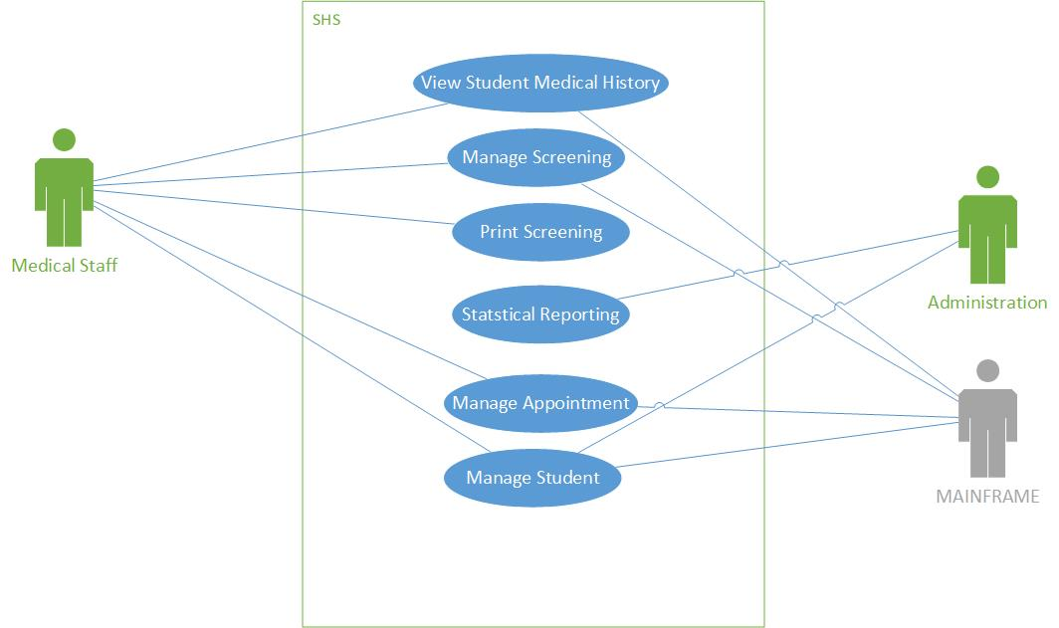

1. **Architectural Significant Use Cases**

|  |  |
| --- | --- |
| **Use Case - Manage Screening** | |
| **Use Case ID** | **UC-001** |
| **Description** | **Allow medical Staff to add, edit student screening into the SHS system** |
| **Primary Actors** | Medical Staff |
| **Secondary Actors** |  |
| **Main Flow of events** | 1. Medical Staff Search Student using information like NRIC, NAME etc. 2. System provides basic student details. 3. Medical staff click on add screening. 4. System provide empty Medical Screening Form. 5. Medical staff enter screening results for the student and click on save. 6. System provide acknowledgement of data insertion by providing summary screen. |
| **Alternative Flow of events** | **Health Screening is already added**   1. Medical staff click on edit screening. 2. System provide Medical Screening Form with prefilled information 3. Medical staff update screening results for the student and click on Save. 4. System provide acknowledgement of data update by providing summary screen. |
| **Pre conditions** | * Student profile is already added in the SHS system. * Medical Staff is login and authenticated |
| **Post conditions** | * Screening is saved successful and available for printing. * Screening is saved unsuccessful and provide retry button. |

|  |  |
| --- | --- |
| **Use Case - Manage Appointment** | |
| **Use Case ID** | **UC-002** |
| **Description** | **Allow medical Staff to schedule appointment for student.** |
| **Primary Actors** | Medical Staff, Mainframe |
| **Secondary Actors** |  |
| **Main Flow of events** | 1. Medical Staff search student using information like NRIC, NAME etc. 2. System provides basic student details. 3. Medical Staff search available appointment slot. 4. System provide list of available slots. 5. Medical staff select slot and request for appointment to Mainframe IT. 6. Mainframe system provide acknowledgement for booking. 7. System acknowledge for appointment booked successfully. 8. Medical Staff print appointment letter. |
| **Alternative Flow of events** | **Appointment Already exists**   1. Medical Staff search student using information like NRIC, NAME etc. 2. System provide existing appointment. 3. Medical Staff print Appointment Letter. |
| **Pre conditions** | * Student profile already exists in the system. * Mainframe system is available. * Medical Staff is login and authenticated |
| **Post conditions** | * Appointment is successful and slot is not available. * Appointment is unsuccessful and slot is available. |

**Use this page if your answers cannot fit in the above boxes.**